Grade 7 Accelerated · Unit 3 · Lesson 3  Exponential Expressions  Independent Set 3.03 ANSWER KEY | Name  Date  Period

Six questions, on your own, in silence. Show the step that does the work.
1. Find the value. 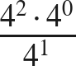

4⁰ is 1; then 4² ÷ 4¹.

2. Find the value. 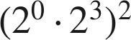
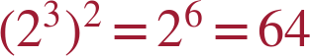

3. Write as one power. 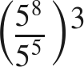
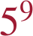
Inside first gives 5³; then (5³)³.

4. Find the value. 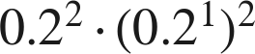


5. Find the value. 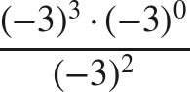
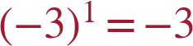

6. Show that 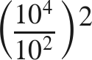 and 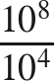 have the same value.
Both are .
Two plans, one value — the point of the lesson.

